- List all the main components you find inside a desktop PC after opening the cabinet, and write a short description (1-2 lines) for each.
Answer:
1. Motherboard: The main circuit board that connects all the computer components and allows them to communicate with each other.
2. CPU (Central Processing Unit): Known as the brain of the computer, it processes instructions and performs calculations.
3. RAM (Random Access Memory): Temporarily stores data and programs currently in use, helping the computer run smoothly.
4. Hard Disk Drive (HDD) / Solid-State Drive (SSD): Stores the operating system, software, games, and files permanently, even when the computer is turned off.
5. Power Supply Unit (PSU): Converts electricity from the wall socket into the power needed by the computer's components.
6. GPU (Graphics Processing Unit): Processes images, videos, and graphics for display on the monitor. It may be built into the CPU or installed as a separate graphics card.
7. Cooling Fan and Heat Sink: Remove heat from the CPU and other components to prevent overheating and maintain proper performance.
8. Optical Disc Drive (Optional): Reads or writes CDs and DVDs, if the computer has one installed.
9. Expansion Cards: Additional cards, such as sound cards, network cards, or graphics cards, that provide extra features.
10. CMOS Battery: A small battery on the motherboard that helps maintain the system clock and BIOS/UEFI settings when the PC is unplugged.
11. SATA and Power Cables: Connect storage drives and other components to the motherboard and power supply.
12. Cabinet (Computer Case): The outer enclosure that holds and protects all the internal components and helps with airflow.
13. Network Interface Card (NIC): Enables the computer to connect to a wired network. It is usually built into the motherboard, but it can also be a separate card.
14. Sound Card: Processes audio input and output for speakers, headphones, and microphones. It is usually integrated into the motherboard.
15. CPU Cooler: A dedicated cooling assembly, usually consisting of a heat sink and fan or a liquid-cooling system, that keeps the processor at a safe temperature.

- Take clear photos or draw labeled diagrams of each step as you disassemble a desktop PC, and organize them in a document with captions explaining what you did at each step. Hint: Include steps like unplugging power, removing side panel, disconnecting cables, and removing RAM, HDD/SSD, and motherboard.
Answer:
Desktop PC Disassembly Guide:

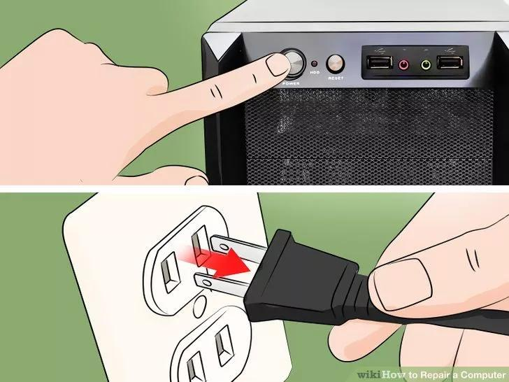
Step 1: Switch Off and Unplug the PC

Caption: I shut down the computer, switched off the power supply, unplugged the power cable, and disconnected all external devices. This helps prevent electric shock and damage to components.

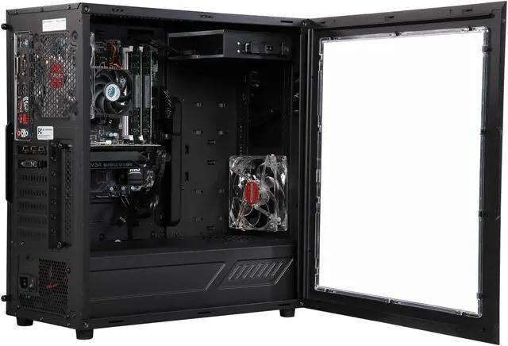
Step 2: Remove the Side Panel
Caption: I removed the screws securing the side panel and carefully slid it off to access the internal components.

Step 3: Identify the Internal Components
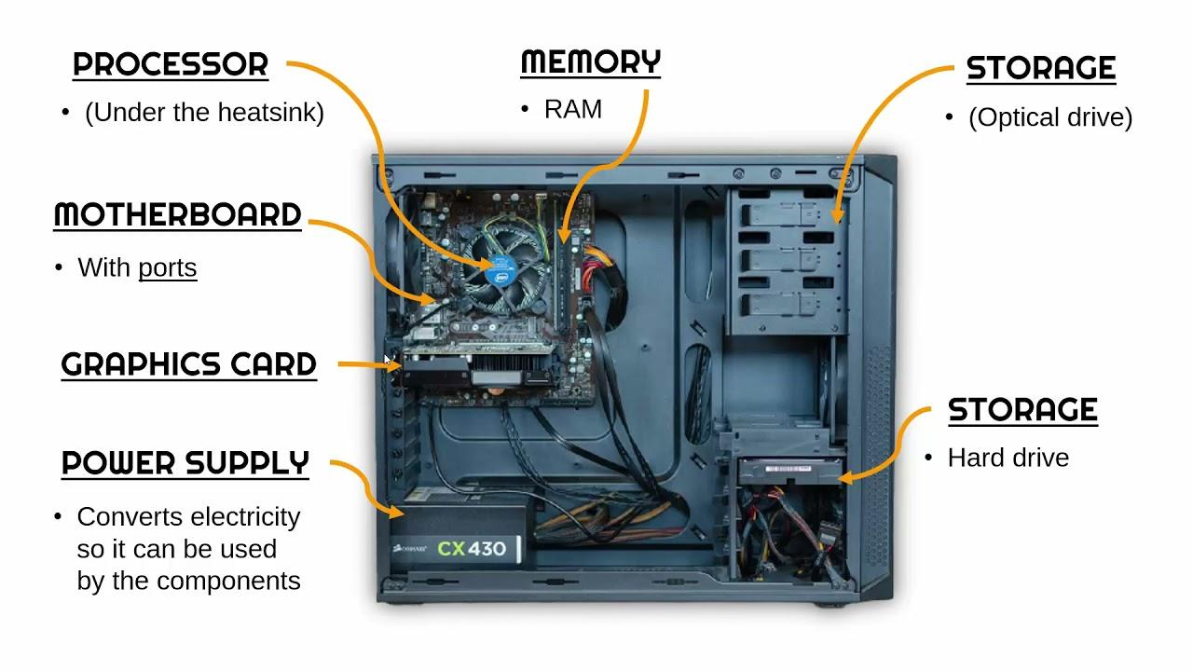
Caption: I identified the motherboard, CPU cooler, RAM, storage drive, power supply, cooling fans, and other components before starting disassembly.

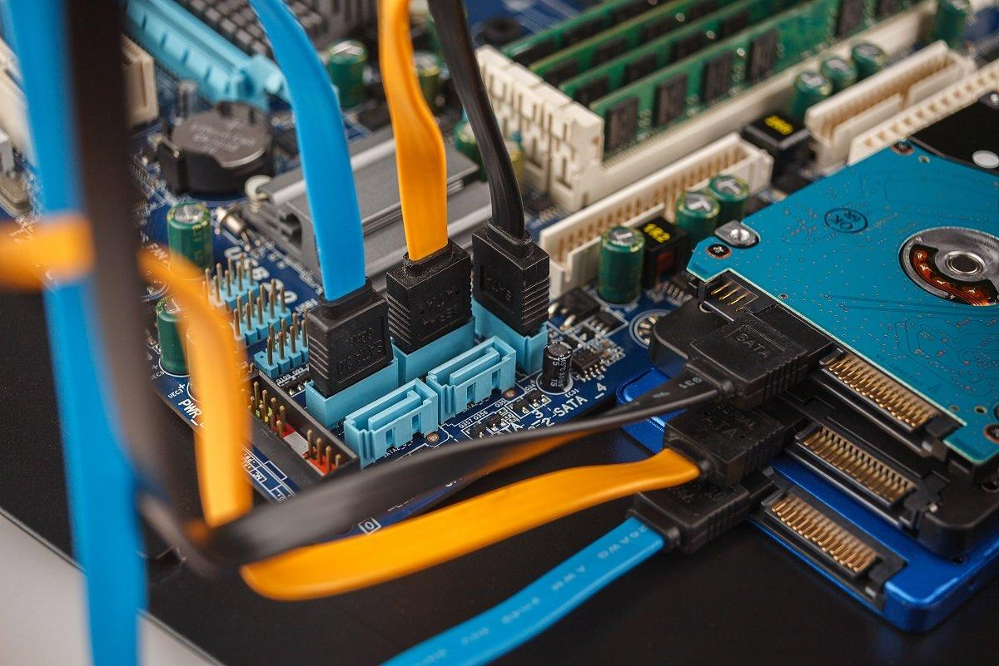
Step 4: Disconnect the Internal Cables
Caption: I carefully disconnected the power and data cables from the motherboard and storage drives. I noted where each cable was connected to make reassembly easier.

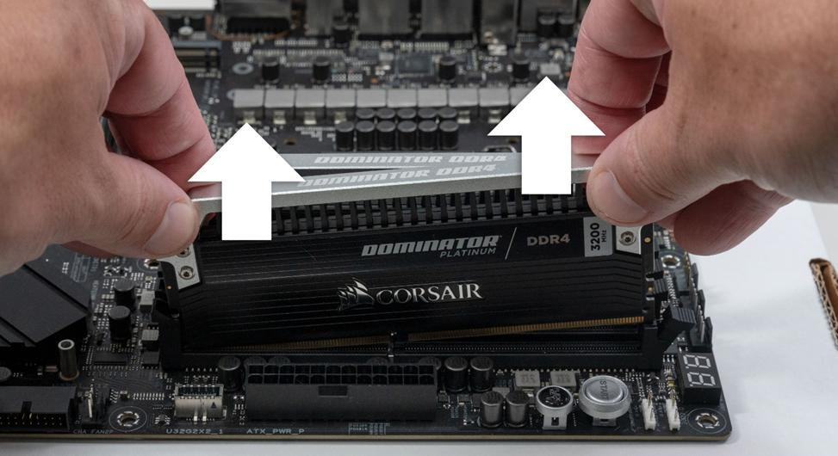
Step 5: Remove the RAM
Caption: I released the clips at the ends of the RAM slot and gently removed the memory module. I held it by its edges to avoid touching the electrical contacts.

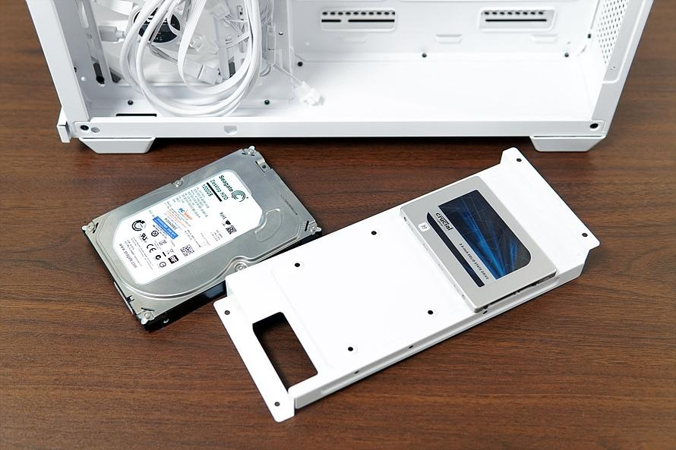
Step 6: Remove the HDD or SSD
Caption: I disconnected the drive's cables, removed the mounting screws or brackets, and carefully took the HDD or SSD out of its bay.

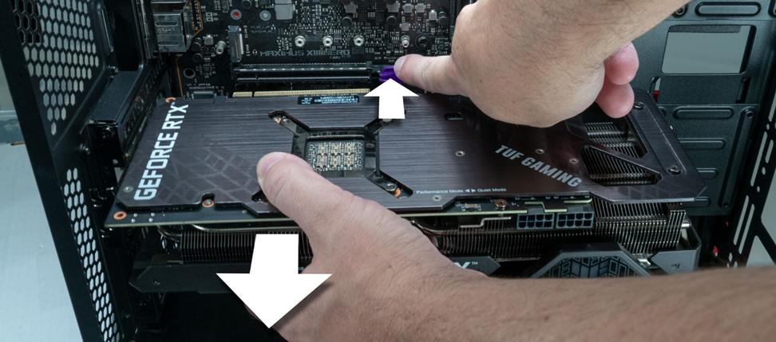
Step 7: Remove the Expansion Cards
Caption: I removed the screws holding the expansion cards, released the PCIe slot clips where necessary, and carefully lifted the cards out of their slots.

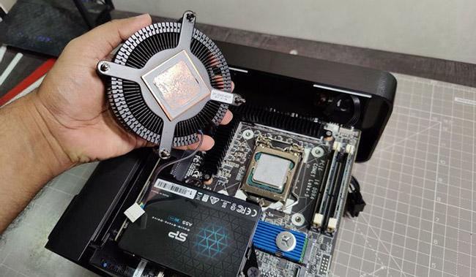
Step 8: Remove the CPU Cooler
Caption: I disconnected the CPU fan cable and carefully released the cooler according to its mounting mechanism. I avoided pulling or twisting the motherboard.

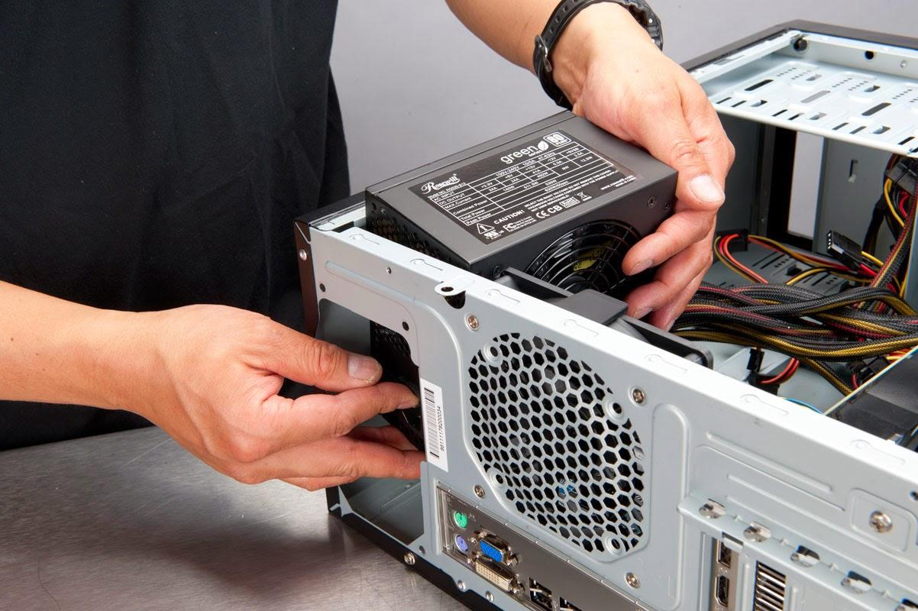
Step 9: Remove the Power Supply Unit
Caption: After confirming that all power cables were disconnected, I removed the screws securing the power supply and carefully took it out of the cabinet. I did not open the power supply itself.

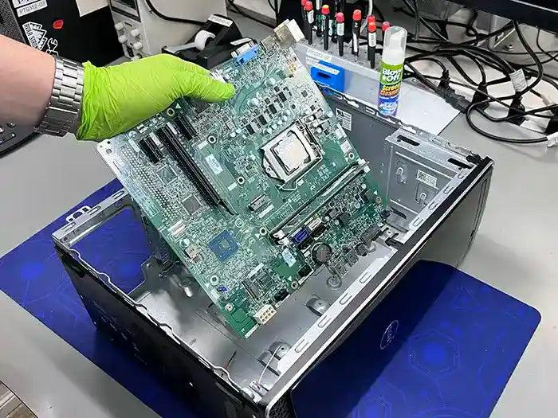
Step 10: Remove the Motherboard
Caption: I checked that all cables and components were disconnected, removed the motherboard mounting screws, and carefully lifted the motherboard out of the cabinet.

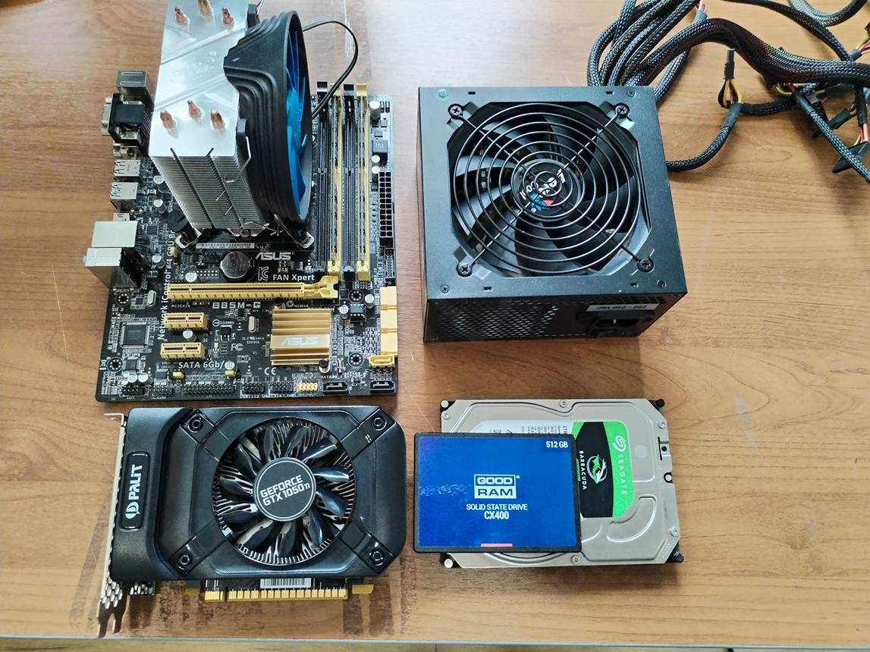
Step 11: Arrange and Label the Components
Caption: I arranged the removed components neatly and labeled them for identification. This helped me understand the function of each component and prepare for reassembly.

- Reassemble the PC you disassembled, documenting each step with a brief explanation of what you connected or installed and why the order matters.
Answer:
Reassemble the PC:-
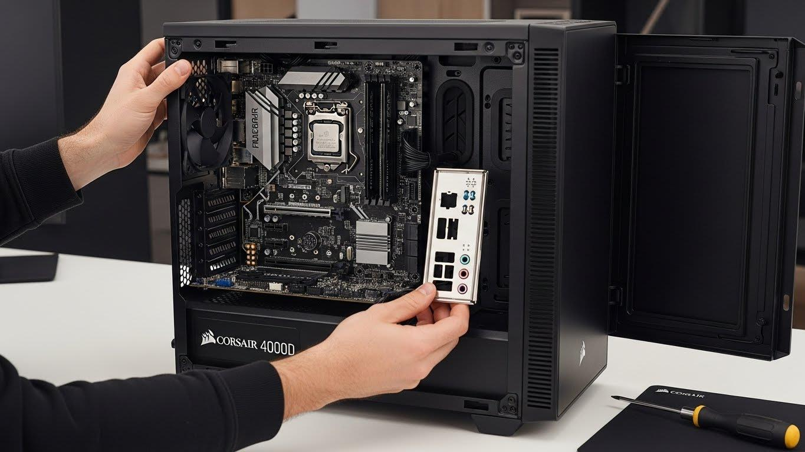
Step 1: Install the Motherboard
I carefully placed the motherboard inside the cabinet, aligned its mounting holes with the standoffs, and secured it with screws. This provides the foundation for connecting all the other components.

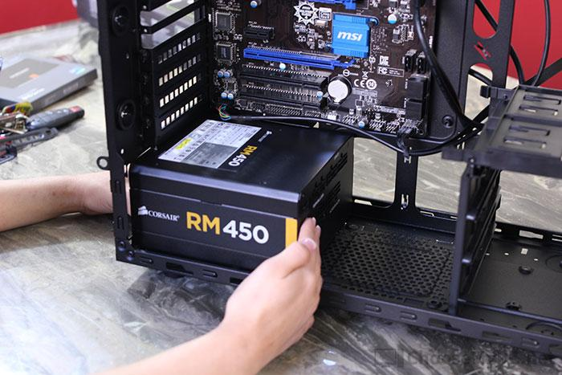
Step 2: Install the Power Supply Unit (PSU)
I placed the power supply in its designated position and secured it with screws. I routed its cables toward the motherboard, storage drives, and other components.

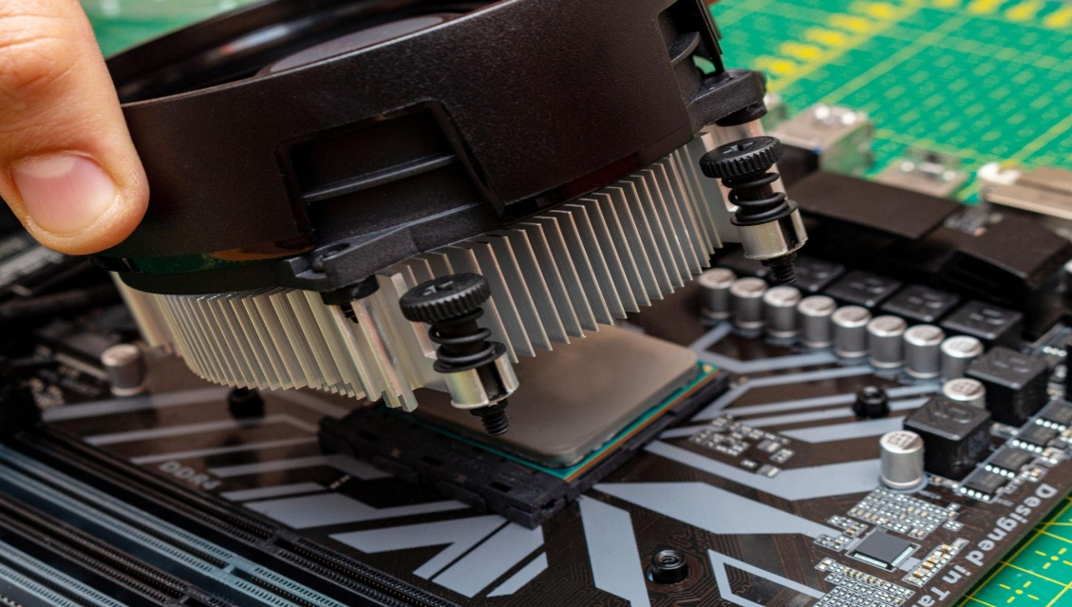
Step 3: Install the CPU Cooler
I checked that the CPU was correctly seated, applied thermal paste if required, and installed the CPU cooler according to the manufacturer's instructions. I connected the cooler fan to the CPU_FAN header.

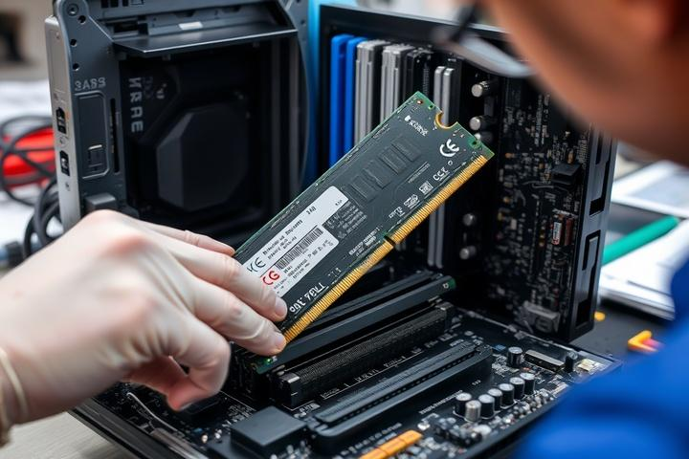
Step 4: Install the RAM

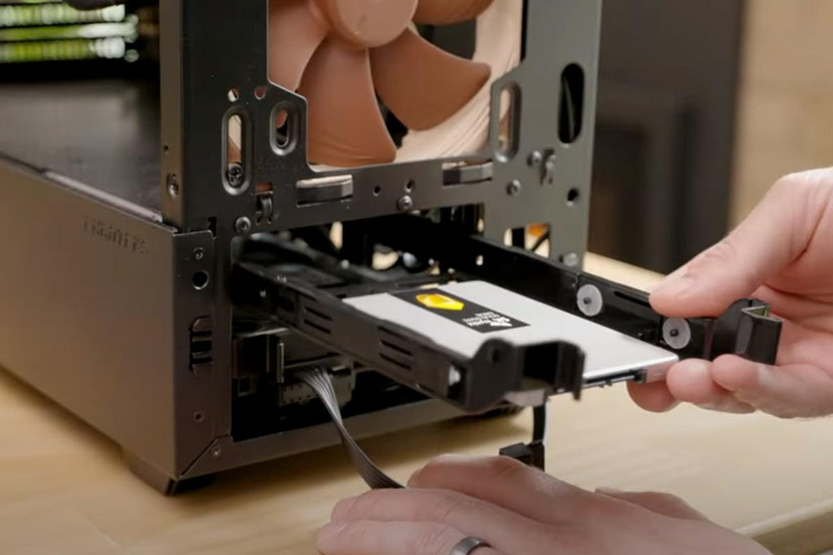
Step 5: Install the HDD or SSD
I aligned the notch on the RAM module with the slot and pressed it in until the retaining clips engaged.

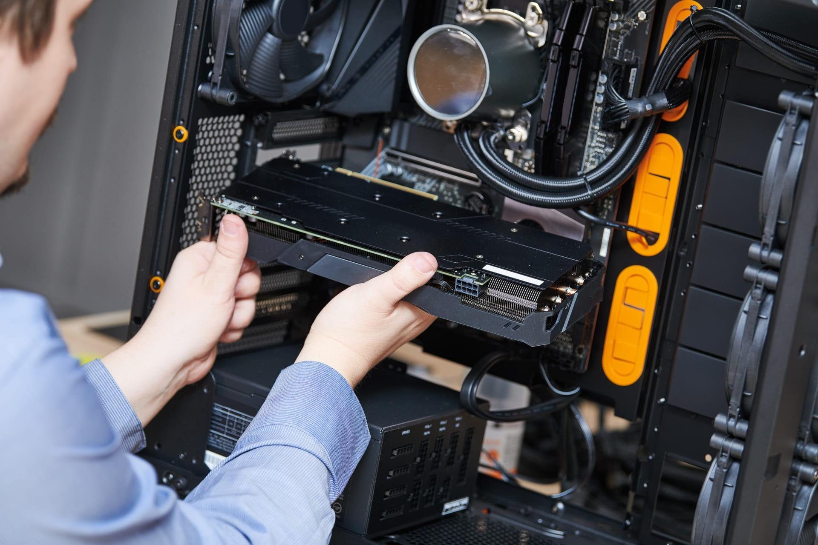
Step 6: Install Expansion Cards
I inserted the graphics card or other expansion cards into the correct motherboard slots and secured them to the cabinet. I connected any required graphics-card power cables.

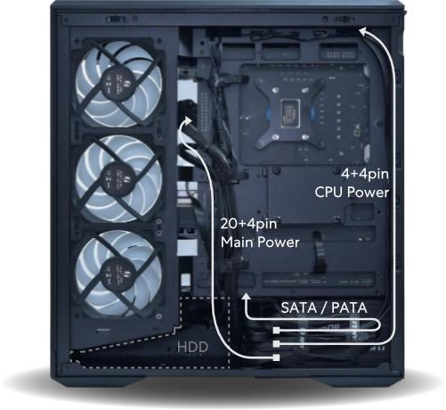
Step 7: Connect the Power and Data Cables
I connected the 24-pin motherboard power cable, CPU power cable, storage data and power cables, CPU fan cable, and other required connectors.

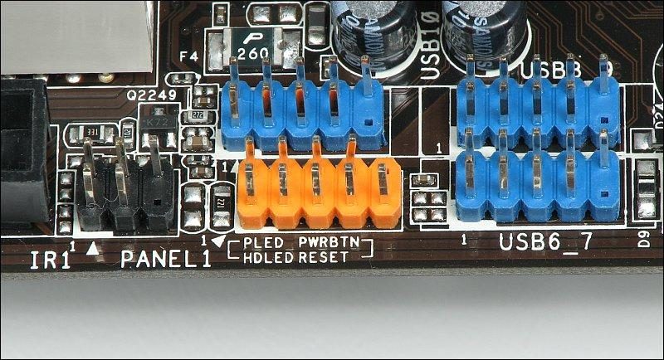
Step 8: Connect the Cabinet Front-Panel Cables
I connected the cabinet's power switch, reset switch, front USB ports, and audio connectors to their correct motherboard headers, following the motherboard manual.

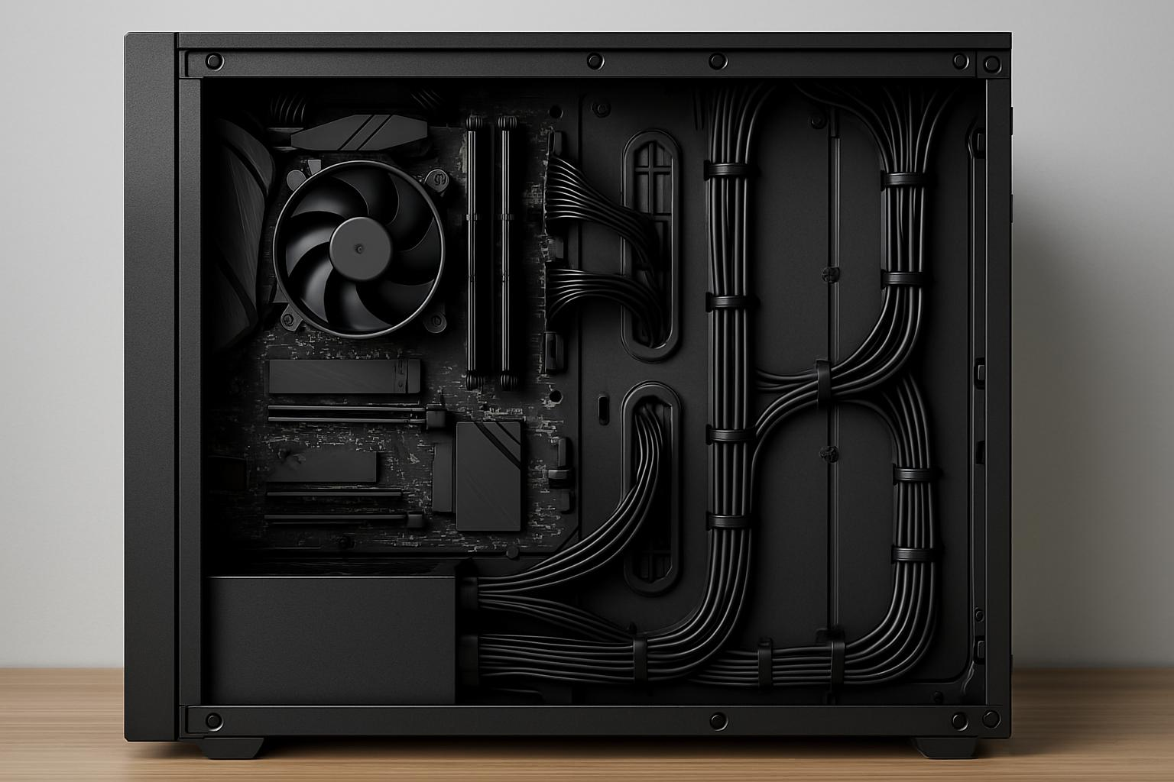
Step 9: Check All Components and Close the Cabinet
I checked that the components were secure, the cables were connected correctly, and no loose screws remained inside. I then reinstalled the side panel.

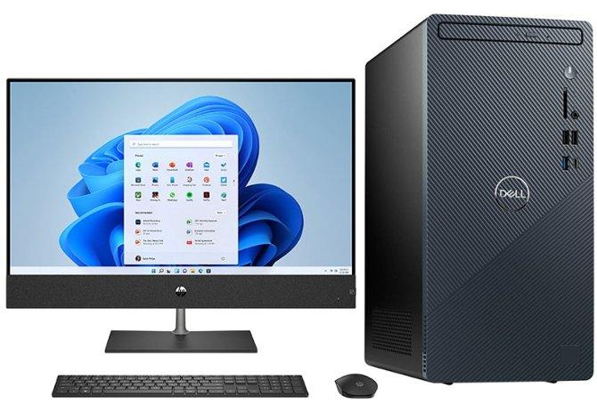
Step 10: Power On and Test the PC
I reconnected the monitor, keyboard, mouse, and power cable. I switched on the PC and checked that it started, displayed an image, and detected its memory and storage devices.

- Create a checklist of safety precautions and tools needed before starting the PC assembly/disassembly process, and explain why each is important.
Answer:
Checklist of Safety Precautions and Tools for PC Assembly/Disassembly
- Safety Precautions Checklist:
- Switch off and unplug the PC
- Disconnect all external cables
- Work on a clean, dry surface
- Use an anti-static wrist strap
- Ground yourself before touching components
- Handle components by their edges
- Keep liquids and food away
- Keep screws organized
- Never open the power supply unit (PSU)
- Take photos before disconnecting cables

- Tools Required Checklist:
- Phillips-head screwdriver
- Anti-static wrist strap
- Small containers or magnetic screw tray
- Cable ties or Velcro straps
- Plastic spudger or pry tool
- Flashlight
- Soft, clean work surface or anti-static mat
- Small brush suitable for electronics
- Important Points to Remember:
  - Always switch off the PC and disconnect the power cable before opening the case.
  - Never force a component or connector; check its locking clips and orientation first.
  - Store removed components in anti-static bags when possible.
  - Keep the CPU, RAM, motherboard, and storage devices away from static electricity.
  - Before powering on the reassembled PC, check that all cables are connected properly and no loose screws remain inside the case.

